Jayden Wilson (Student)
Rport
Airline – Distinct

Contents
Requirements 2
Design 4
Code 5
Tests 5
16/12/2025 5
18/12/2025 5
User Guide 11
Introduction 11
Launching the Application 11
Navigating the Main Menu 15
Managing Customers 15
Managing Flights 16
Managing Bookings 17
Managing Routes 18
Exporting Data 19

Requirements
Flight Booking System — Project Brief
Objective
Create a Java-based booking system for a small passenger airline.
The system should collect airline booking data and export it into CSV files.
These CSV files will later be imported into a MariaDB flight database.

System Requirements
The program must be able to store:
- Customer details
- Flight booking information
- Individual flight details
- Scheduled route information
Output requirement:
CSV files (customers.csv, bookings.csv, flights.csv, routes.csv)

Class Structure
Customer
- CustomerID
- FirstName
- LastName
- Email
- Phone
- Address
Booking
- BookingID
- BookingDate
- CustomerID (refers to Customer)
- FlightID (refers to Flight)
Flight
- FlightID
- FlightNumber
- DepartureAirport
- ArrivalAirport
- DepartureDateTime
- ArrivalDateTime
Route
- RouteID
- RouteName

Deliverables
You must submit:
- UML Use Case Diagram
- UML Class Diagram
- Complete Java project (OOP, saves to CSV)
- Test log with screenshots or video evidence
- User documentation / user manual

Summary
This system is a data-entry tool for airline records.
Its purpose is to collect information through a Java application, then export as CSV, which is later imported to a MariaDB database.

Design
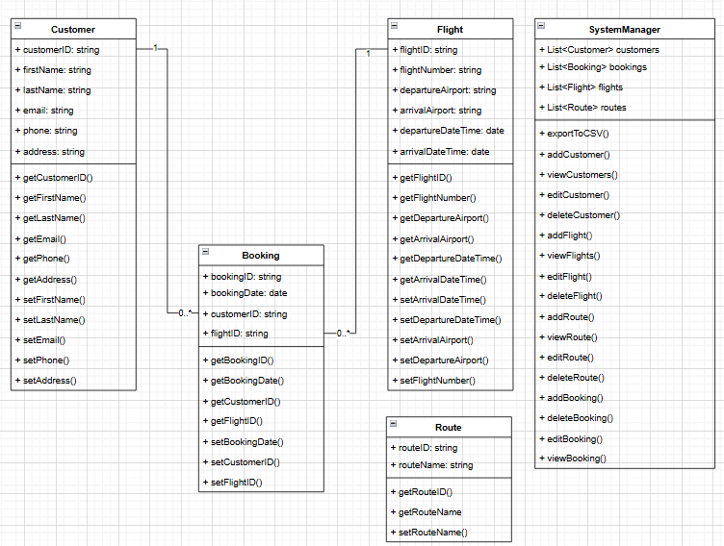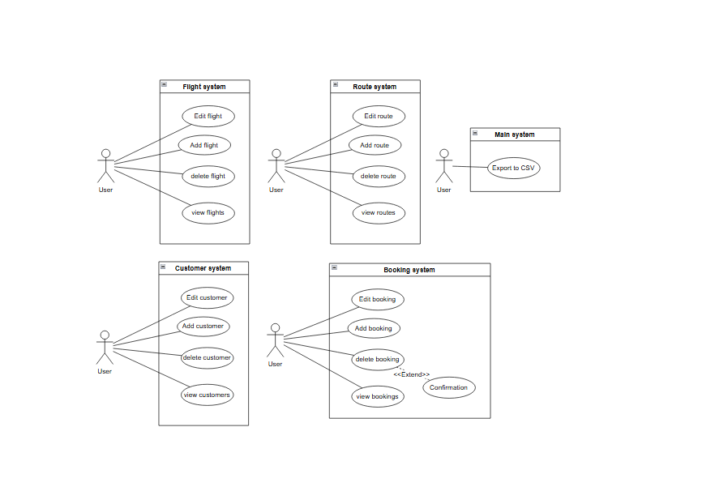

Code
Code can be found on GitHub https://github.com/Jayden-Wilson-01/Airline

Tests

16/12/2025
Candidate: Jayden-James Wilson Project title: Airline – Distinct

Test case | Test data | Expected result | Actual result | Comments
List of options |  | Show a list of possible options you can choose from | List of different options show. | 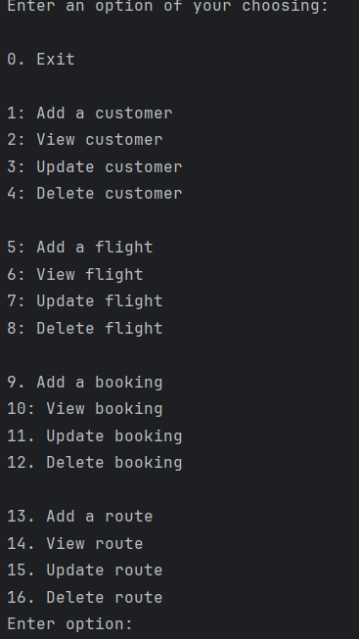
Add customer | “Customer1”, “Jayden”, “Wilson”, jayden@mail.com, “098765432345”, “BT727SY” | Should be able to add these values | Able to add these values | 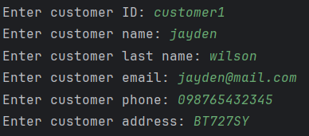  Note that there is no further testing for value types as all values here are of type string.
View customer | “Customer1” | All associated information from the selected customer | Customer does not exist error but works if you first create a customer then view it (only if 1 customer exists) | 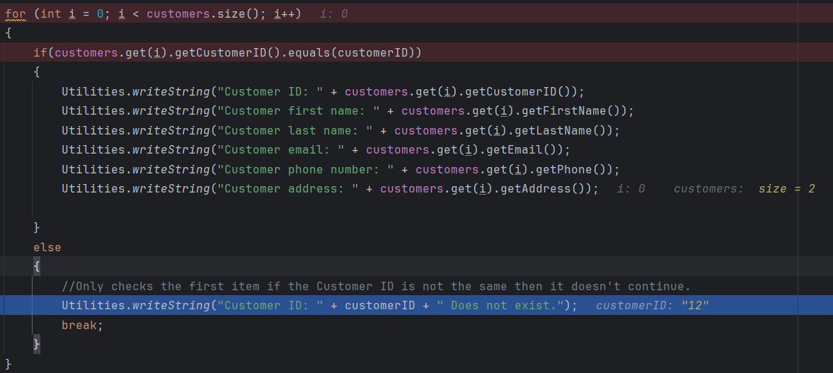  Only checks the first item if the Customer ID is not the same then it doesn't continue. This will need to be fixed first as verification for other tests rely on the ability to view if a customer has changed. We will continue with the ability you can do it as long as there is only 1 customer in the list.  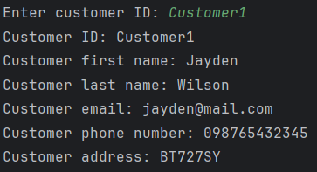
Update customer | “Customer1”, “Jay”, “Wil”, jay@mail.com,  “09876543”, “adfgtrer” | Update customer with the newly inputted data | After viewing the customer I can confirm it updates the details | 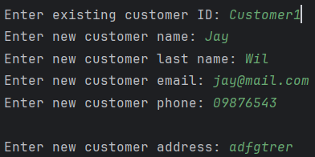  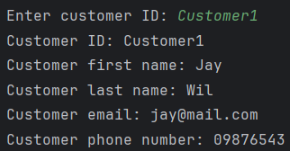  Only checks the first item if the Customer ID is not the same then it doesn't continue. This will need to be fixed first as verification for other tests rely on the ability to view if a customer has changed. We will continue with the ability you can do it as long as there is only 1 customer in the list.
Delete customer | “Customer1” | Should delete the specified customer | Does in fact delete the customer | 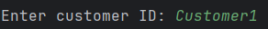  Only checks the first item if the Customer ID is not the same then it doesn't continue. This will need to be fixed first as verification for other tests rely on the ability to view if a customer has changed. We will continue with the ability you can do it as long as there is only 1 customer in the list.  prevent customer being deleted unless referenced booking is deleted first
Add flight | “flight1”, “fight298261”, “Aberdeen”, “London”, “16/12/2025”, “16/12/2025” | Should add a new flight based on the information provided | Does in fact create a new flight | 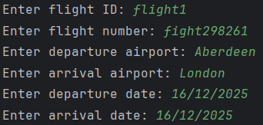  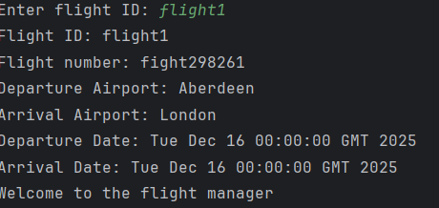
View flight | “flight1” | Should see the associated flight information | Do indeed see the flight information | Only checks the first item if the flight ID is not the same then it doesn't continue. This will need to be fixed first as verification for other tests rely on the ability to view if a flight has changed. We will continue with the ability you can do it as long as there is only 1 flight in the list.
Update flight | “flight1”, “flight123”, “London” “Aberdeen”, “17/12/2025”, “18/12/2025” |  |  | 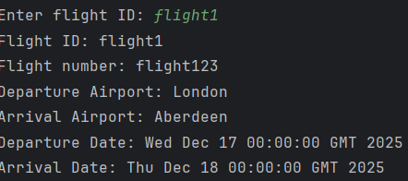  Only checks the first item if the flight ID is not the same then it doesn't continue. This will need to be fixed first as verification for other tests rely on the ability to view if a flight has changed. We will continue with the ability you can do it as long as there is only 1 flight in the list.
Update flight but with incorrect date format | “nsuquq” | When inputting the incorrect date it should ask you to enter again | It does indeed do as expected | 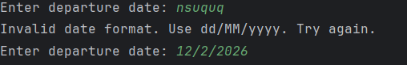
Update flight departure and arrival dates |  | Arrival date should not be before or can only be 1 day before minimum for time zones as you can be a day ahead or behind | System currently does not handle this.
Delete flight | “flight1” | Should delete the specified flight | Does in fact delete the specified flight | Only checks the first item if the flight ID is not the same then it doesn't continue. This will need to be fixed first as verification for other tests rely on the ability to view if a flight has changed. We will continue with the ability you can do it as long as there is only 1 flight in the list.  prevent flight being deleted unless referenced booking is deleted first
Add route | “route1”, “route1234” | Should be able to add a route | Does in fact add route | 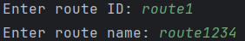
View route | “route1” | Should view specified route | Does In fact show specified route | 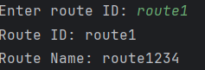  Only checks the first item if the route ID is not the same then it doesn't continue. This will need to be fixed first as verification for other tests rely on the ability to view if a route has changed. We will continue with the ability you can do it as long as there is only 1 route in the list.
Update route | “route1”, “route987” | Should be able to update route with new data | Can indeed update route | 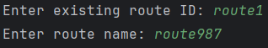  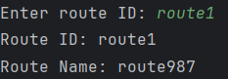  Only checks the first item if the route ID is not the same then it doesn't continue. This will need to be fixed first as verification for other tests rely on the ability to view if a route has changed. We will continue with the ability you can do it as long as there is only 1 route in the list.
Delete route | “route1” | Should be able to delete route | Can indeed delete route | Only checks the first item if the route ID is not the same then it doesn't continue. This will need to be fixed first as verification for other tests rely on the ability to view if a route has changed. We will continue with the ability you can do it as long as there is only 1 route in the list.
Add booking | “booking1”, “16/12/2025”, “customer1”, “flight1” | Should be able to add a booking | You can indeed add a booking. | 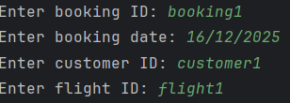  foreign id’s should probably refer to genuine and existing bookings
view booking | “booking1” | Should be able to view booking | You can in fact view a booking | 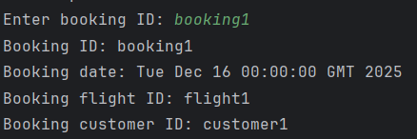  Only checks the first item if the booking ID is not the same then it doesn't continue. This will need to be fixed first as verification for other tests rely on the ability to view if a booking has changed. We will continue with the ability you can do it as long as there is only 1 booking in the list.
Update booking | “booking1” | Should be able to update booking. | You can update booking  date is asked for again in invalid | 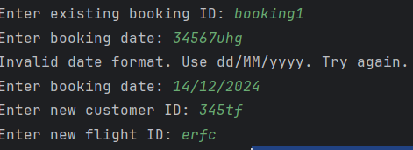  should check if the referenced IDs for flight and customer are existent.  Only checks the first item if the booking ID is not the same then it doesn't continue. This will need to be fixed first as verification for other tests rely on the ability to view if a booking has changed. We will continue with the ability you can do it as long as there is only 1 booking in the list.
Delete booking | “booking1” | Should delete booking | Does indeed delete booking | Only checks the first item if the booking ID is not the same then it doesn't continue. This will need to be fixed first as verification for other tests rely on the ability to view if a booking has changed. We will continue with the ability you can do it as long as there is only 1 booking in the list.

Test case | Test data | Expected result | Actual result | Comments
View customer | “Customer1” | All associated information from the selected customer | Works as expected
Update customer | “Customer1”, “Jay”, “Wil”, jay@mail.com,  “09876543”, “adfgtrer” | Update customer with the newly inputted data | After viewing the customer I can confirm it updates the details
Delete customer | “Customer1” | Should delete the specified customer | Does in fact delete the customer | prevent customer being deleted unless referenced booking is deleted first
View flight | “flight1” | Should see the associated flight information | Do indeed see the flight information
Update flight | “flight1”, “flight123”, “London” “Aberdeen”, “17/12/2025”, “18/12/2025”
Update flight but with incorrect date format | “nsuquq” | When inputting the incorrect date it should ask you to enter again | It does indeed do as expected
Update flight departure and arrival dates |  | Arrival date should not be before or can only be 1 day before minimum for time zones as you can be a day ahead or behind | System currently does not handle this.  System now handles so you can have an arrival date anything on or after departure date | 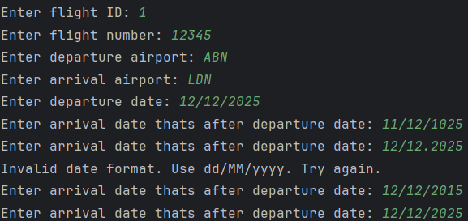
Delete flight | “flight1” | Should delete the specified flight | Does in fact delete the specified flight | prevent flight being deleted unless referenced booking is deleted first
View route | “route1” | Should view specified route | Does In fact show specified route
Update route | “route1”, “route987” | Should be able to update route with new data | Can indeed update route
Delete route | “route1” | Should be able to delete route | Can indeed delete route
Add booking | “booking1”, “16/12/2025”, “customer1”, “flight1” | Should be able to add a booking | You can indeed add a booking. | foreign id’s should probably refer to genuine and existing bookings
view booking | “booking1” | Should be able to view booking | You can in fact view a booking
Update booking | “booking1” | Should be able to update booking. | You can update booking however it should check if the referenced IDs for flight and customer are existent.  date is asked for again in invalid
Delete booking | “booking1” | Should delete booking | Does indeed delete booking

18/12/2025
Candidate: Jayden-James Wilson Project title: Airline – Distinct

Test case | Test data | Expected result | Actual result | Comments
List of options |  | Show a list of available options | You can show a list of available options
Create booking | booking id: b1  customer id: c5  Customer id: c1  flight id: f5  flight id: f2  booking date: 23/12/12 | . add a new booking and be able to reference existing flights and customers | You are able add a new booking and be able to reference existing flights and customers | 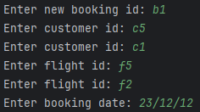  If a booking with the same id you will be asked to enter a new different one.  If a flight or customer doesn’t exust you will be asked to enter id that do.
Update booking | booking id: b1  Customer id: c2  flight id: f2  booking date: 14/12/12 | . update existing booking and be able to reference existing flights and customers | You are able to update booking and be able to reference existing flights and customers | 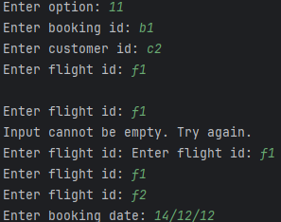  Will only let you update customer where the id exists  If a flight or customer doesn’t exist you will be asked to enter id that do.
View Booking | Booking id: b1 | View details of existing booking | You are able to view details of existing booking | 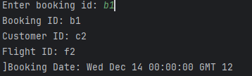  Will only let you view booking where the id exists
Delete booking | Booking id: b1 | Should delete existing booking | Does delete existing booking | Will only let you delete customer where the id exists
Add customer | customer id: c1  customer name: jayden  customer last name: wilson  customer email: jayden@mail.com  customer phone: 0987654  customer address: DH726HW | Should be able to add a new customer | You can add a new customer | 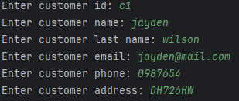  If a customer with the same id you will be asked to enter a new different one.
Update customer | Customer id: c1  customer name: jayden-james  customer last name: wilson  customer email: jayden@mail.com  customer phone: 2345678  Enter new customer address: BS636DY | Should be able to update an existing customer | You can update existing customer | 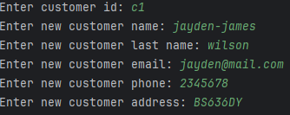  Will only let you update customer where the id exists
View customer | Customer id: c1 | Should be able to view existing customer | You are able to view existing customer | 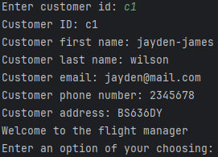  Will only let you view customer where the id exists
Delete Customer | Customer id: c1 | Should be able to delete existing customer | You can delete existing customer | Will only let you delete customer where the id exists
Add flight | flight id: f1  flight number: flight101  departure airport: ABDN  arrival airport: LODN  departure date: 26/05/2024  arrival date thats after departure date: 24/05/2024  arrival date thats after departure date: 26/05/2024 | Should be able to add a flight | You can add a new flight | 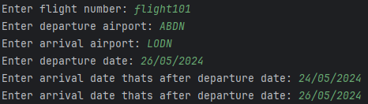  Will only let you put in a date on or after the departure date  If a flight with the same id you will be asked to enter a new different one.
Update flight | flight number: flight102  departure airport: ABDN  arrival airport: LODN  departure date: 25/05/2025  arrival date: 25/05/2025 | Should be able to update flight | You can update flight | 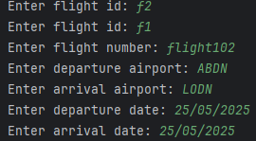  Will only let you update flight where the id exists
View flight | Flight id :f1 | Should be able to view specific flight | You can view specific flight | 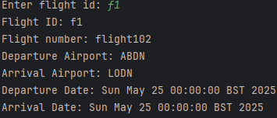  Will only let you view flight where the id exists
Delete flight | Flight id: f1 | Should be able to delete a specific flight | You can delete a specific flight | Will only let you delete flight where the id exists
Add route | route id: route2  route name: route202 | Should be able to add a new route | You can create a new route | 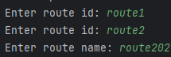  If a route with the same id you will be asked to enter a new different one.
Update route | route id: route2  route name: route203 | Should be able to update specific route | You can update specific route | 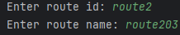  If a route with the same id you will be asked to enter a new different one.
View route | route id route2 | Should be able to view specific route | You can view specific route | 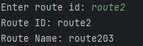  If a route with the same id you will be asked to enter a new different one.
Delete route | Route id: route2 | Should be able to delete specific route | You can delete specific route | If a route with the same id you will be asked to enter a new different one.
Customers to CSV |  | Should be able to export customer list as a CSV file | You can export customer list as CSV | 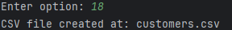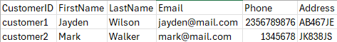
Flights to CSV |  | Should be able to export flight list as a CSV file | You can export flight list as CSV | 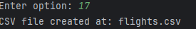
Bookings to CSV |  | Should be able to export booking list as a CSV file | You can export booking list as CSV | 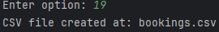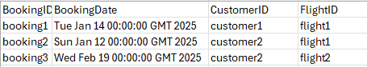
Routes to CSV |  | Should be able to export route list as a CSV file | You can export routes list as CSV | 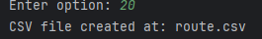  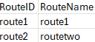

User Guide

Introduction
Airline Distinct is a streamlined terminal-based management system designed for efficient data entry and organization. This application provides a centralized interface to manage Flights, Bookings, Customers, and Routes, featuring a robust export tool that generates categorized CSV files for external reporting and data analysis.
Please note that green text means data that you can input for corresponding fields

Launching the Application
To effectively use this application please follow the instructions below:
- Go to a storage location on your device you wish to store the application in this guide that will be C:\
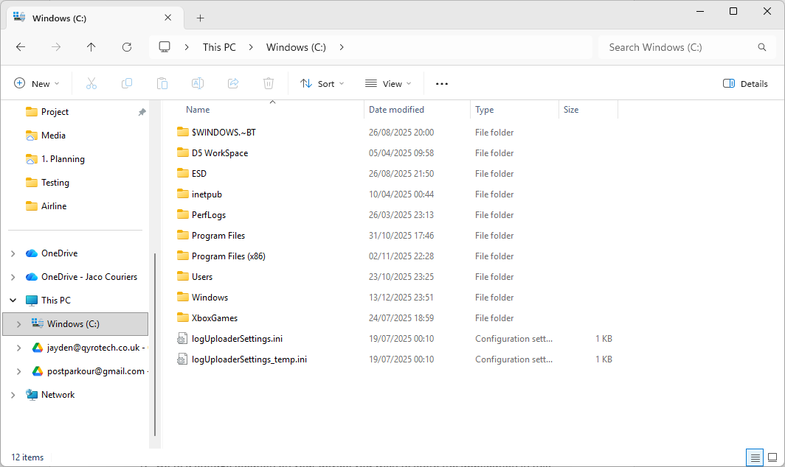

- Now that you have done that type CMD in the top search bar
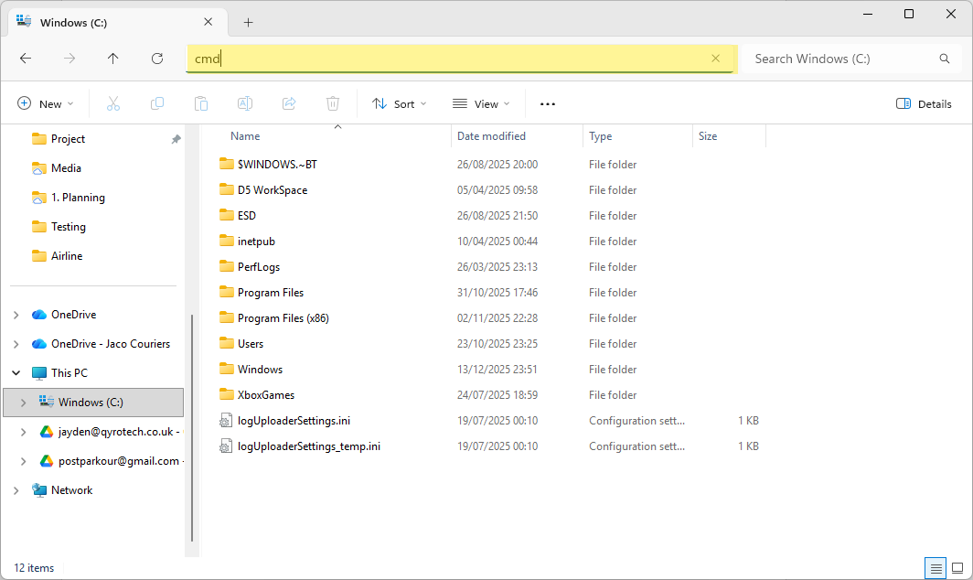
- You will now see a terminal window. Type the following
git clone https://github.com/Jayden-Wilson-01/Airline.git
You will then see a few messages this is to tell you that the files are being downloaded correctly. If you do not have git install it here.
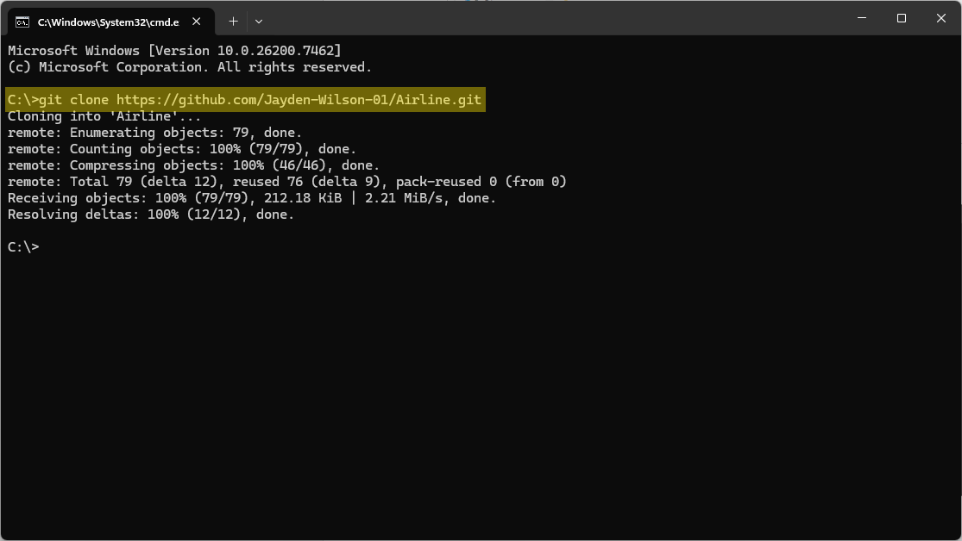

- If you go back to your folder in this case C:\ you will see a folder called Airline
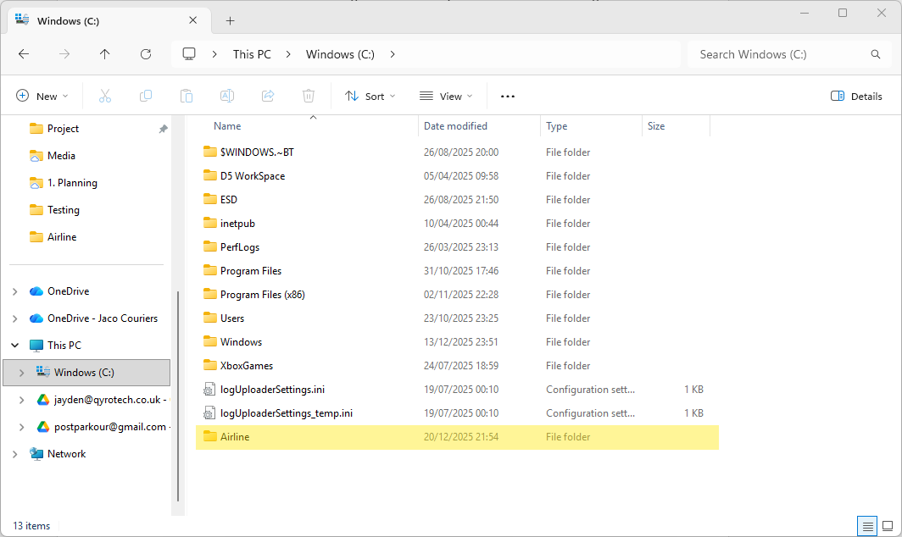
- Now open IntelliJ, click on open folder then use Airline.
If you do not have IntelliJ download it here
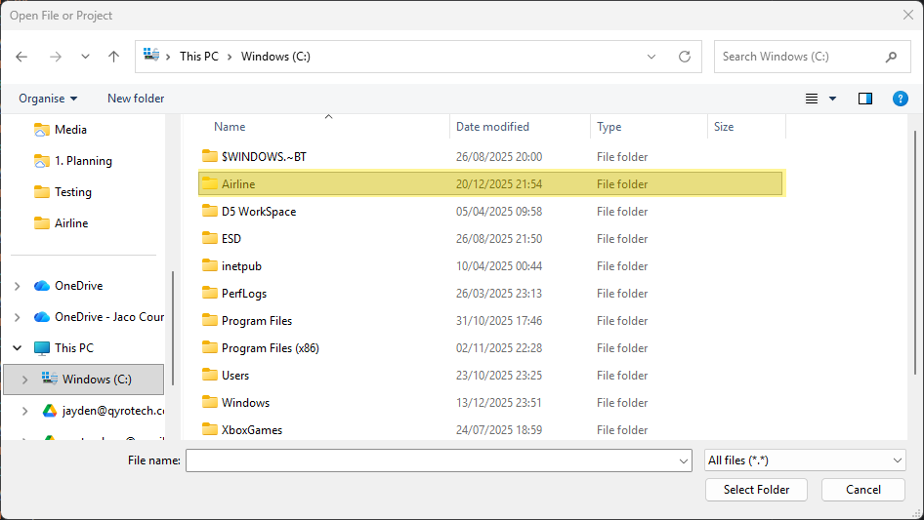

- Now you will see IntelliJ with the project opened. Navigate to main.js and then click run
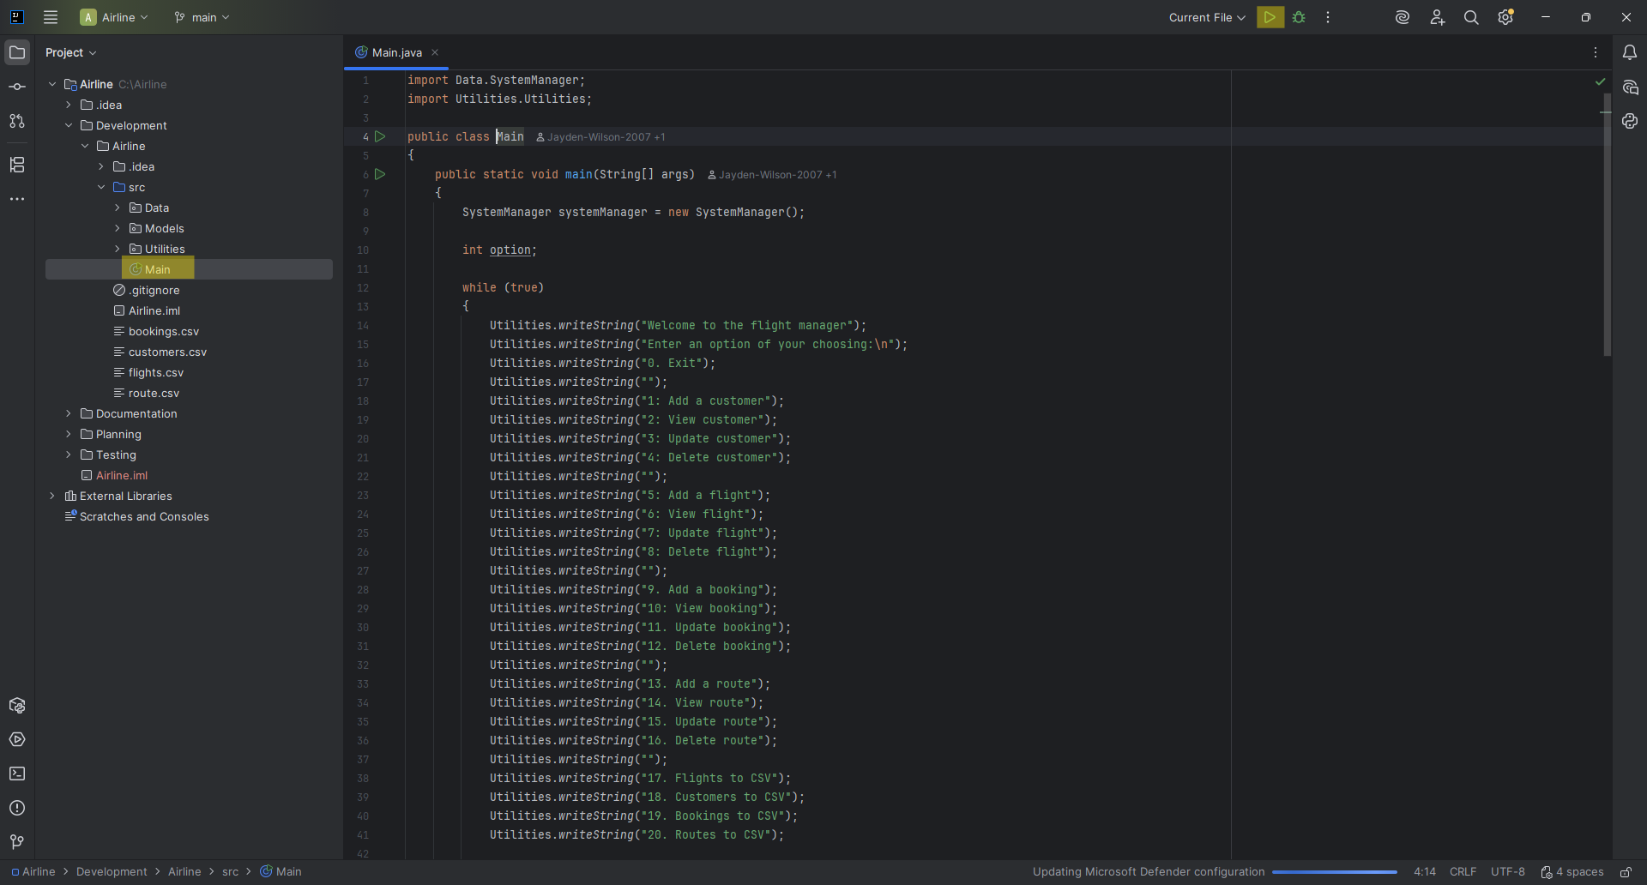
- Now you will see a list of options. You have successfully launched the app.
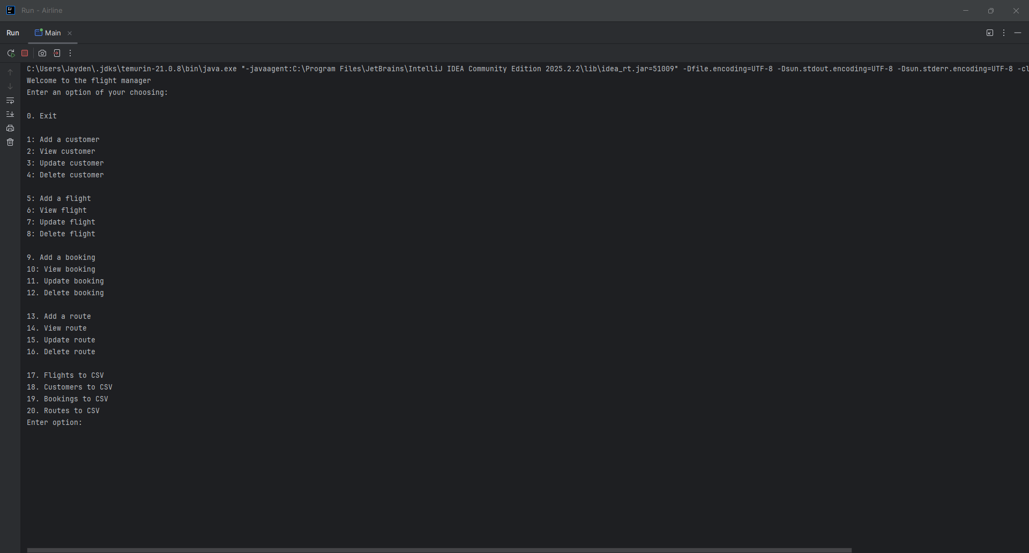

Navigating the Main Menu
The application uses a numeric selection system. To perform an action: Type the number corresponding to your desired task, then press Enter to confirm.
Category | Add | View | Update | Delete | Export to CSV
Customers | 1 | 2 | 3 | 4 | 18
Flights | 5 | 6 | 7 | 8 | 17
Bookings | 9 | 10 | 11 | 12 | 19
Routes | 13 | 14 | 15 | 16 | 20

Managing Customers
- To add a customer type 1 then enter data for the fields, below is an example:
CustomerID is case sensitive
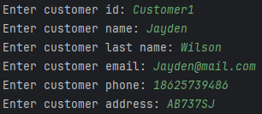
- To view a customer type 2 Then enter a customerID, below is an example:
CustomerID is case sensitive. CustomerID must exist.
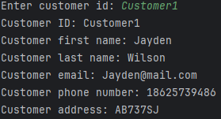

- To update a customer type 3 then enter an existing customerID then enter data for the fields, below is an example: CustomerID is case sensitive. CustomerID must exist.
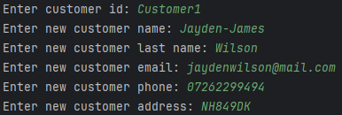
- To delete a customer type 4 then enter an existing customerID, below is an example: CustomerID is case sensitive. CustomerID must exist.

Managing Flights
- To add a flight type 5 then enter data for the fields, below is an example:
FlightID is case sensitive. Arrival date can only be the same or after departure date.
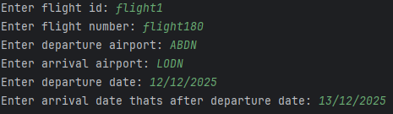
- To view a flight type 6 Then enter a flightID, below is an example:
FlightID is case sensitive. FlightID must exist.
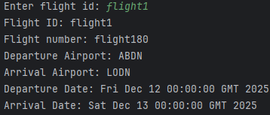

- To update a flight type 7 then enter an existing flightID then enter data for the fields, below is an example: FlightID is case sensitive. Arrival date can only be the same or after departure date. FlightID must exist.
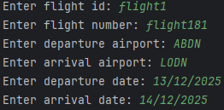
- To delete a flight type 8 then enter an existing flightID, below is an example: FlightID is case sensitive. FlightID must exist.

Managing Bookings
- To add a booking type 9 then enter data for the fields, below is an example:
BookingID, CustomerID, FlightID are case sensitive. CustomerID and FlightID must be exist.
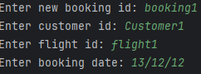
- To view a booking type 10 Then enter a bookingID, below is an example:
BookingID is case sensitive. BookingID must exist.
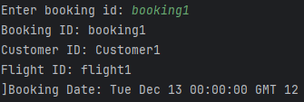

- To update a booking type 11 then enter an existing bookingID then enter data for the fields, below is an example: BookingID, CustomerID, FlightID are case sensitive. BookingID, CustomerID and FlightID must be exist.
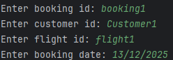
- To delete a booking type 12 then enter an existing bookingID, below is an example: BookingID is case sensitive

Managing Routes
- To add a route type 13 then enter data for the fields, below is an example:
RouteID is case sensitive.
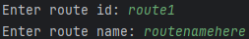
- To view a route type 14 Then enter a routeID, below is an example:
RouteID is case sensitive. RouteID must exist.
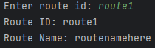
- To update a route type 15 then enter an existing routeID then enter data for the fields, below is an example:
RouteID is case sensitive. RouteID must exist.
- To delete a route type 16 then enter an existing routeID, below is an example: RouteID is case sensitive. RouteID must exist.

Exporting Data
- To export customers, type 18. You will then find the CSV file in this case in C:\Airline
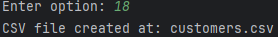
- To export flights, type 17. You will then find the CSV file in this case in C:\Airline
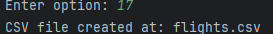
- To export bookings, type 19. You will then find the CSV file in this case in C:\Airline
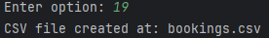
- To export routes, type 20. You will then find the CSV file in this case in C:\Airline
